**Experiment 3:**  Write a program to find area of circle, square, triangle and rectangle and perform equivalence class testing.

**Code:**

#include<iostream>

using namespace std;

int main()

{

int ch;

char c;

float b, h, a;

start:

cout<<"\n1 Triangle";

cout<<"\n2 Square";

cout<<"\n3 Rectangle";

cout<<"\n4 Circle";

cout<<"\n5 Exit\n";

cout<<"Enter your choice";

cin>>ch;

switch(ch)

{

case 1 :

b:

cout<<"\nEnter the base of the triangle (1-200)";

cin>>b;

if ((b<=0)||(b>200))

{

cout<<"\nInvalid entry for base \n";

goto b;

}

h:

cout<<"\nEnter the height of the triangle (1-200)";

cin>>h;

if ((h<=0)||(h>200))

{

cout<<"\nInvalid height\n";

goto h;

}

a= 0.5*b*h;

cout<<"\nThe area is "<< a;

cout<<"\nWant to enter more?(y/n) ";

cin>>c;

if((c=='y')||(c=='Y'))

goto start;

break;

case 2 :

s:

cout<<"\nEnter the side of the square (1-200)";

cin>>b;

if ((b<=0)||(b>200))

{

cout<<"\nInvalid entry for base \n";

goto s;

}

a= b*b;

cout<<"\nThe area is "<< a;

cout<<"\nWant to enter more?(y/n) ";

cin>>c;

if((c=='y')||(c=='Y'))

goto start;

break;

case 3:

d:

cout<<"\nEnter the base of the triangle (1-200)" ;

cin>>b;

if((b<=0)||(b>200))

{

cout<<"\nInvalid entry for base \n";

goto d;

}

p:

cout<<"\nEnter the height of the triangle (1-200) ";

cin>>h;

if ((h<=0)||(h>200))

{

cout<<"\nInvalid height\n";

goto p;

}

a=b*h;

cout<<"\nThe area is "<< a;

cout<<"\nWant to enter more?(y/n) ";

cin>>c;

if((c=='y')||(c=='Y'))

goto start;

break;

case 4:

t:

cout<<"\nEnter the radius of the circle ";

cin>>b;

if ((b<=0)||(b>200))

{

cout<<"\nInvalid entry for base \n";

goto t;

}

a= 3.14*b*b;

cout<<"\nThe area is "<< a;

cout<<"\nWant to enter more?(y/n)";

cin>>c;

if ((c=='y')||(c=='Y'))

goto start;

break;

case 5:

exit(0);

break;

default :

cout<<"\n WRONG CHOICE";

goto start;

}

return 0;

}

**Output :**

**Area Of Triangle:**

|  |  |  |  |
| --- | --- | --- | --- |
| **Test case** | **H** | **B** | **Expected Output** |
| 1 | 0 | 100 | Invalid Output |
| 2 | 100 | 100 | 5000 |
| 3 | 201 | 100 | Invalid Output |
| 4 | 100 | 0 | Invalid Output |
| 5 | 100 | 100 | 5000 |
| 6 | 100 | 201 | Invalid Output |

**Area of Square :**

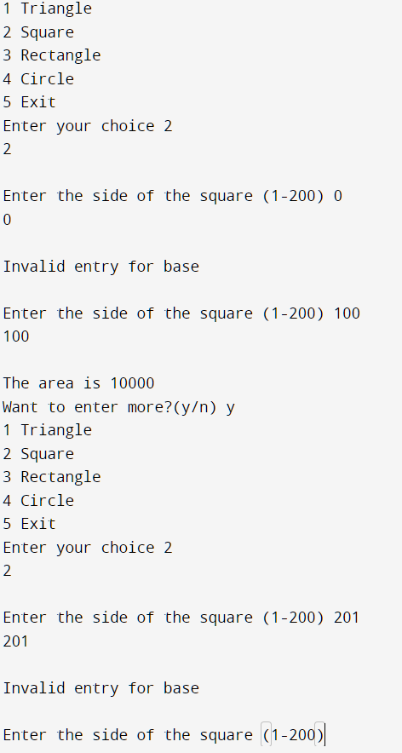

|  |  |  |
| --- | --- | --- |
| **Test Case** | **S** | **Expected Output** |
| 1. | 0 | Invalid Output |
| 2 | 100 | 10000 |
| 3 | 201 | Invalid Output |

**Area of Rectangle :**

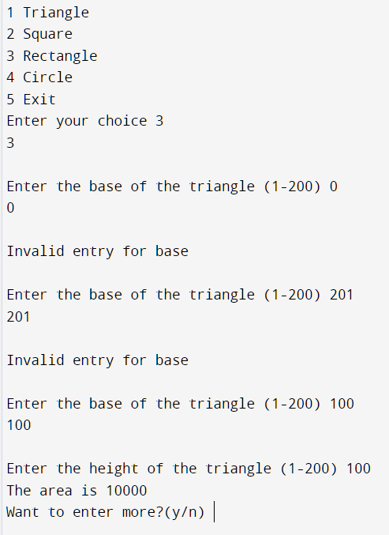

|  |  |  |  |
| --- | --- | --- | --- |
| **Test Case** | **L** | **B** | **Expected Output** |
| 1 | 0 | 100 | Invalid input |
| 2. | 100 | 100 | 10000 |
| 3. | 201 | 100 | Invalid input |
| 4. | 100 | 0 | Invalid input |
| 5. | 100 | 100 | 10000 |
| 6. | 100 | 201 | Invalid input |

**Area of Circle :**

|  |  |  |
| --- | --- | --- |
| **Test Case** | **Radius** | **Generated Output** |
| 1. | 0 | Invalid Output |
| 2. | 100 | 31400 |
| 3. | 201 | Invalid Output |